General features
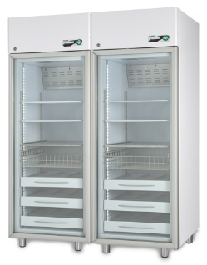  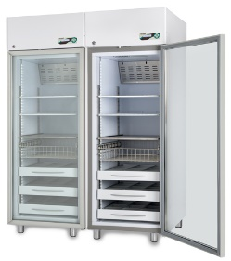  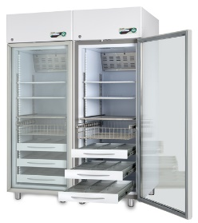Disclaimer:  Images are purely indicative. The features and the accessories of the products may differ according to model and application. | Temperature range | Adjustable +2°C / +15°C for both compartments
 | Factory setpoint | Increment | +5°C | 0.1°C for both compartments
 | Ambient working class| Climatic class | From +16°C to +38°C | N-ST
 | Nominal capacity | 700 + 700 lt (24,7 + 24,7 cu ft)
 | Gross capacity | Net capacity | 620 + 620 lt (21,9 + 21,9 cu ft) | 620 + 620 lt (21,9 + 21,9 cu ft)
 | External dimensions (W x D x H) | 150 (75 + 75) x 84,5 x 210 cm
 | Internal dimensions (W x D x H) | 60 x 68,5 x 150 cm (X2)
 | Net weight without any internal fittings | 288 kg
 | Package dimensions | Weight | No. 2 cardboards on pallet 77 x 90 x 214 cm each | weight 161 kg each
 |  | No. 2 wooden crates on pallet 84 x 94 x 214 cm each | weight 174 kg each
 | Structure | No. 2 monocoque type body, made of plasticized, non-toxic white steel interior/exterior, coated with a special antibacterial-type film, or in inner 18/10 Aisi 304 stainless steel. Rounded corners and tray-type inner bottom.
 | Insulation type | High density (43 kg/m3) in-walls injected PUF, without any CFC, environmental-friendly, water-foam based.
 | Insulation thickness | 75 mm
 | Feet | No. 4 adjustable feet
 | Door | No. 2 doors made of tempered glass, triple thickness, self-closing thanks to the spring hinge and 90°stop position.
 | Lightning | Full LED, all length of inner chamber, automatic switching on at door opening or from the display when the door is closed.
 | Internal fittings | Customizable and height adjustable, it can mix independently:  wire shelves supported by adjustable clips (dim.cm 56x65)  fully extractible drawers made of aluminium, with dividers (WxDxH): cm 15x60x7,5 (nr 3 compartments)  fully extractible drawers made of aluminium, without dividers (WxDxH): cm 49x60x7,5  st. steel wire basket on telescopic slides (WxDxH): cm 53,8x63x14,8  st. steel wire drawers on telescopic slides (WxDxH): cm 53,8x60,5x6,2  st. steel wire shelves supported by adjustable clips (dim.cm.56x66)
 | Suggested internal fittings | No. 8 wire shelves (8 + 8)
 | Refrigeration system
 | Refrigeration | Professional, ventilated, forced, hermetic compressor type.  No. 2 separate and independent cooling systems, one for each compartment.
 | Defrost | Automatic, adaptive, including condensate water vaporisation
 | Refrigerant | Natural R290
 | GWP | ODP | 3 | 0

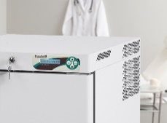 | Electronic controller
 | Controller | ECT-F PLUS controller
 | Type of controller | Electronic controller, back-lit alphanumeric LCD display and resolution 0,1°C
 | Power switch | Integrated in user’s interface
 | Security features | Settable user password
 | Alarm system | Visual and acoustic for temperature alarms and failures such as:  Open door  High temperature  High temperature caused by power failure.  Low temperature  Power failure (alarm back up up to 48h)  Clogged condenser  Faulty batteries  Any functional failure/faulty parts
 | Data and event recordings | Last 12 events available on the display
 | Settable temperature alarm limits | Yes, through parameter adjustment
 | Control sensors | NTC type probes
 | Connection for remote alarm signalisation | Ready on the board, remote on request
 | Temperature recording | Log of minimum and maximum temperature reached, manual reset
 | Data export | Not available
 | Electrical and functional data
 | Standard power supply | 230V / 1ph / 50Hz
 | Standard plug type | Schuko type “G”
 | Compressor protection | Overload Protector included
 | Power absorption/current | kW 0,12 + 0,12 (Amp 0,7 + 0,7)
 | Inrush current | Amp 2,5 + 2,5
 | Noise level | <50 + 50 dBA
 | Heat emission according to EN 12900 | W 40 + 40
 | Hold over time at 20°C ambient (air) | 5 h (from +5°C to +15°C)
 | Energy consumption at 20°C ambient | 1 + 1 kWh/24h
 | Conformity
 | Directives and regulations | Directive 2006/42/EC (Machine directive)  Directive 2011/65/EC (ROHS II)  Directive 2015/863/ EC (ROHS III)  Directive 2012/19/EC (RAEE)  Directive 2014/30/EC (EMC)  Directive 2014/35/EC (LVD)  Regulation (EU) 517-2014 (F-gas)  Regulation (EU) 1907-2006_REACH
 | Available certificate | CE
 | Application environment | Non-flammable, non-explosive, non-corrosive, with adequate air exchange

Accessories available on request

Lock with key

External dry contact

Anty-freeze safety
DIN 13277 conformity (includes anty-freeze safety) | Includes: anti-freezer safety, key lock, buffer batteries for power failure alarm and external terminal board with dry contact

Temperature chart recorder
Solid type door | Please refer to LABOR series

Additional wire shelf kit

Extractible drawer on telescopic slides

Extractible drawer without inner dividers on telescopic slides

St. steel wire shelf kit

St. steel wire drawer on telescopic slides

St. steel wire basket on telescopic slides

Perforated stainless steel shelf

Lockable drawer for narcotics H mm 100

Rack 140x500x150H mm (max 3 per each shelf)

Plexiglas front panel for extractible drawer

Castors kit with brakes

Internal Socket (no.1)

35 mm access port with stopper

Port hole mm 15

Humidity sensor

PT100 sensor with free contacts

Mains voltage stabilizer

Non-standard plug and cable

Power 220V/60Hz

Power 115V/60Hz

Wooden crate package

